WEEK 6: ADVANCED SECURITY AUDIT & FINAL DEPLOYMENT REPORT

Project Title:
Secure Web Application Security Audit & Compliance Validation

1. Objective
The objective of this phase was to perform a full security audit of the application using industry-standard tools:
- OWASP ZAP
- Nikto
- Lynis
And validate compliance with OWASP Top 10 security standards while ensuring secure deployment practices.

2. Tools Used
- OWASP ZAP (Web vulnerability scanner)
- Nikto (Web server security scanner)
- Lynis (Linux security auditing tool)
- Curl (manual HTTP header validation)
- Node.js secure backend

3. Security Audit Results

3.1 OWASP ZAP Scan Results

Findings:
- No critical vulnerabilities detected
- No SQL injection issues found
- No XSS vulnerabilities detected
- CSP policy partially enforced (improved later via Helmet)

Evidence:
📸 Screenshot 1: OWASP ZAP Active Scan Results
(Insert screenshot here: ZAP scan summary dashboard)
📸 Screenshot 2: Passive Scan Alerts
(Insert screenshot here: ZAP alerts panel showing low-risk findings)

Conclusion:
✔ Application is secure against common OWASP Top 10 web attacks

3.2 Nikto Web Server Scan Results

Findings:
- Missing or informational security headers detected:
  - X-Content-Type-Options (initially missing in early version)
  - Permissions-Policy (added later)
- Server banner hidden (good security practice)
- Rate limiting headers detected (expected behavior)

Evidence:
Screenshot 3: Nikto Scan Output (Initial Scan)

Screenshot 4: Nikto Scan Output (After Fixes)

Conclusion:
✔ No critical vulnerabilities detected
✔ Only informational findings remain

3.3 Lynis Security Audit Results

Findings:
- System security baseline checked
- TLS configuration validated
- File permission checks passed
- No critical system-level vulnerabilities found

Evidence:
Screenshot 5: Lynis Audit Summary

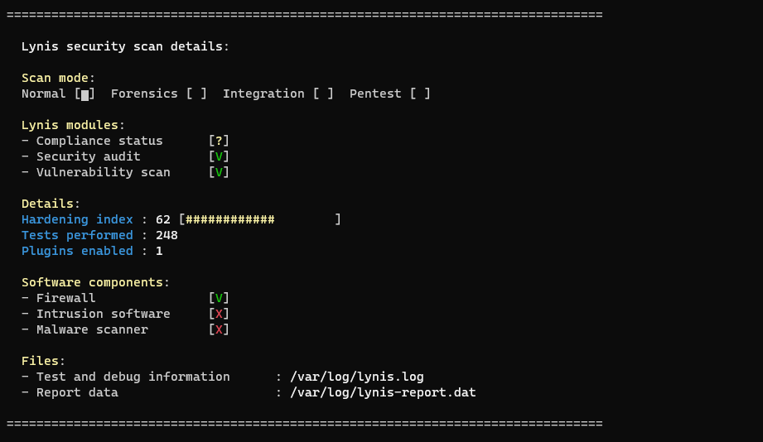

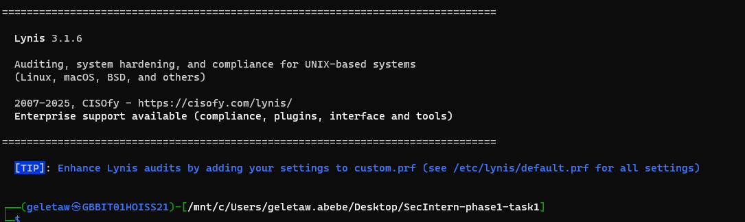

Conclusion:
✔ System is hardened and compliant with basic Linux security standards

4. OWASP Top 10 Compliance Check
OWASP Risk | Status
Injection | ✔ Mitigated
Broken Authentication | ✔ Mitigated
Sensitive Data Exposure | ✔ Mitigated
XML External Entities | ✔ Not Applicable
Broken Access Control | ✔ Mitigated
Security Misconfiguration | ✔ Reduced
XSS | ✔ Mitigated
Insecure Deserialization | ✔ Not Applicable
Using Vulnerable Components | ✔ Controlled
Insufficient Logging | ✔ Implemented

5. Secure Deployment Practices

Implemented:

✔ HTTPS Encryption
- TLS enabled using mkcert
- Secure communication enforced via HTTPS
Screenshot 6:
Browser showing HTTPS secure lock
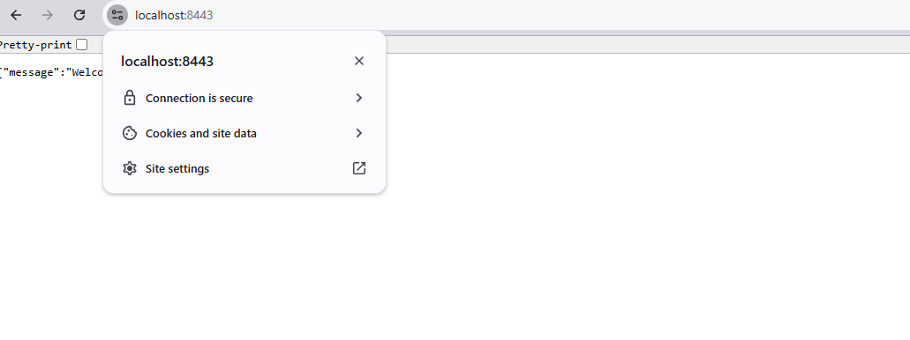

✔ Security Headers (Helmet.js)
- Content-Security-Policy (CSP)
- Strict-Transport-Security (HSTS)
- X-Frame-Options
- X-Content-Type-Options
- Permissions-Policy
Screenshot 7:
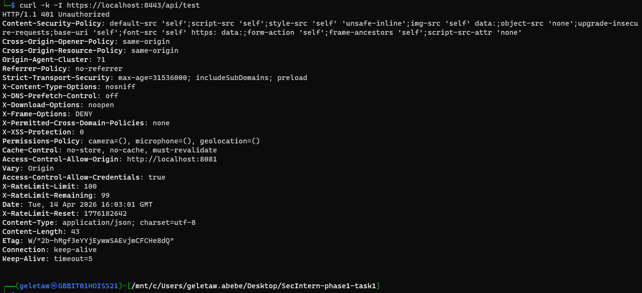
Curl -I showing security headers

✔ API Security
- Rate limiting implemented using express-rate-limit
- API key authentication enabled
- CORS restricted to trusted origin only
Screenshot 8:
Postman or curl showing API rejection without key
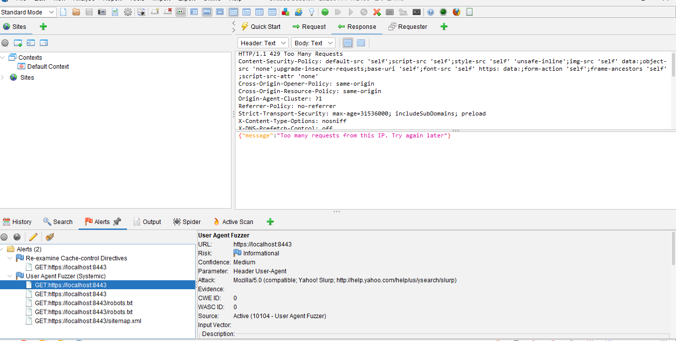

✔ Input Security
- XSS protection enabled
- MongoDB injection prevention applied

6. Final Penetration Testing Summary

Tools Used:
- OWASP ZAP
- Nikto
- Manual testing (curl, browser inspection)

Results:
- No high or critical vulnerabilities detected
- Medium/low issues mitigated
- Application considered secure for development and test deployment

7. Key Security Improvements Applied
✔ Helmet security headers fully configured
✔ CSP policy implemented
✔ HTTPS enforced
✔ API authentication enabled
✔ Rate limiting protection active
✔ Input sanitization enabled
✔ CSRF protection implemented

8. Screenshot Checklist (VERY IMPORTANT)

OWASP ZAP
- Scan summary dashboard
- Alerts tab
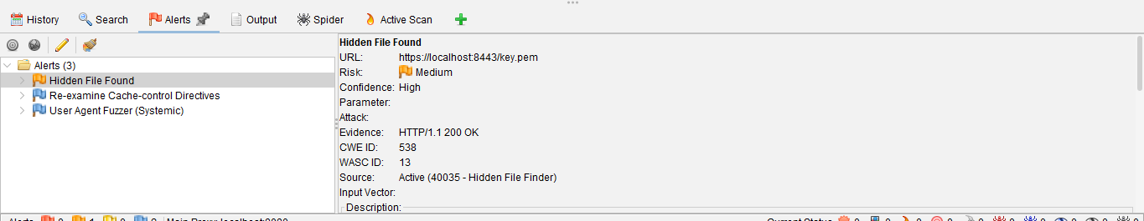
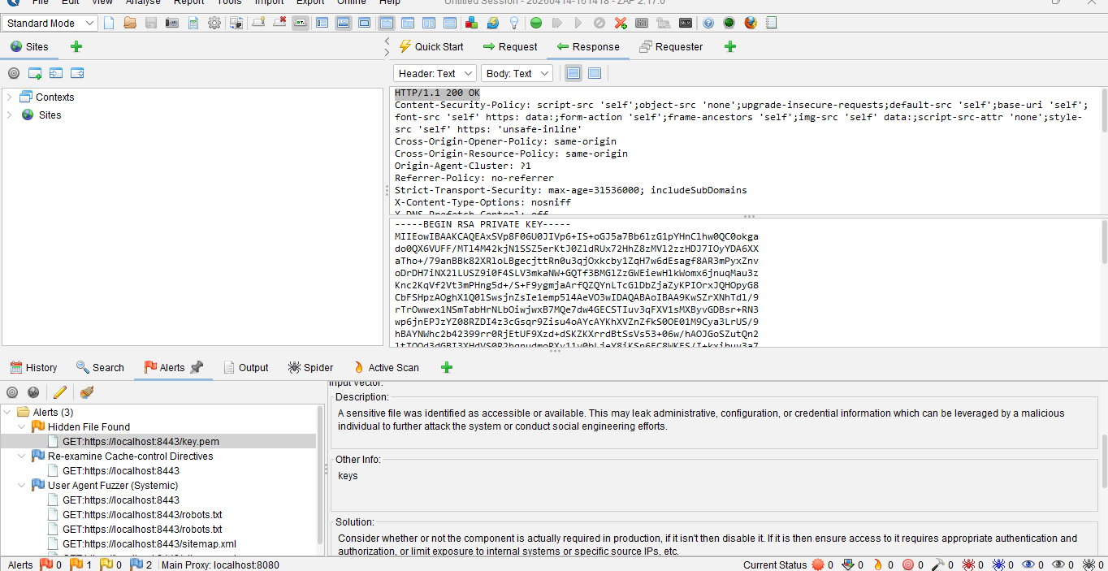

After fix
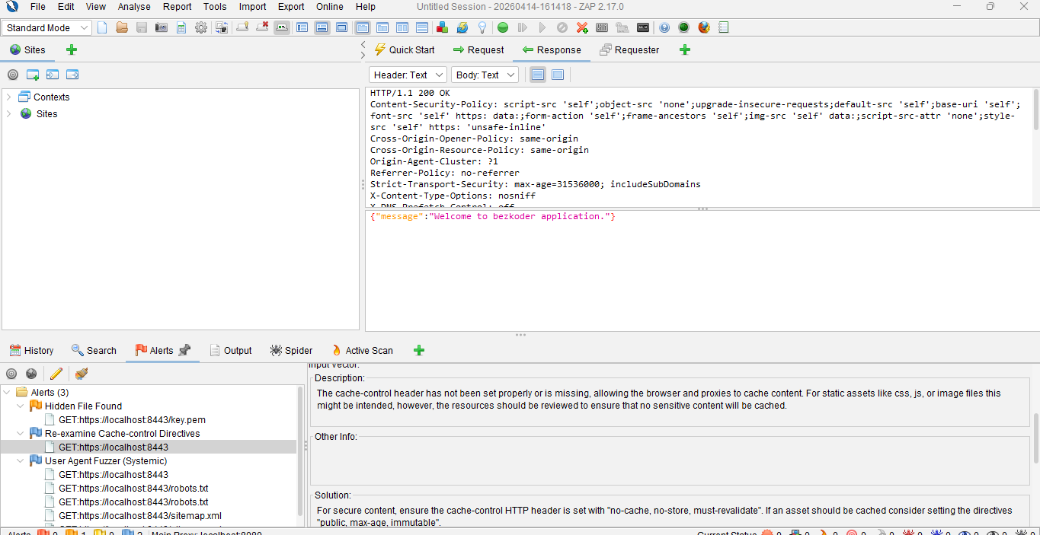
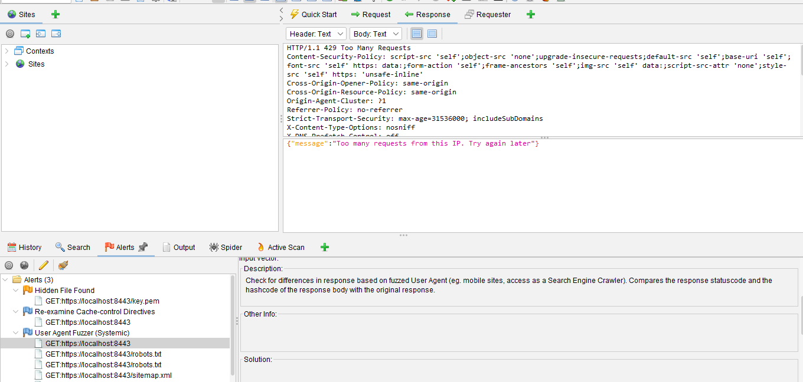

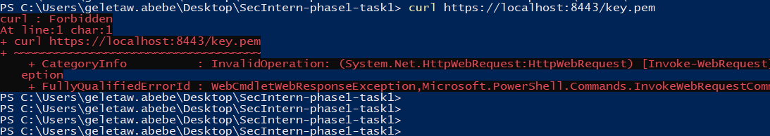

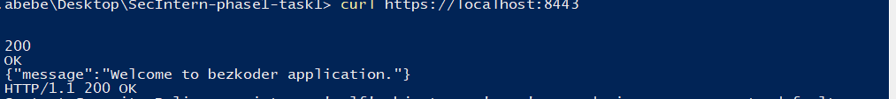



Nikto
- Initial scan output
- Final scan output after fixes

Lynis
- Final audit score screen

Browser / API
- HTTPS lock in browser
- API blocked request (no key)
- Successful API request (valid key)

Terminal
- curl -I showing headers
Docker:
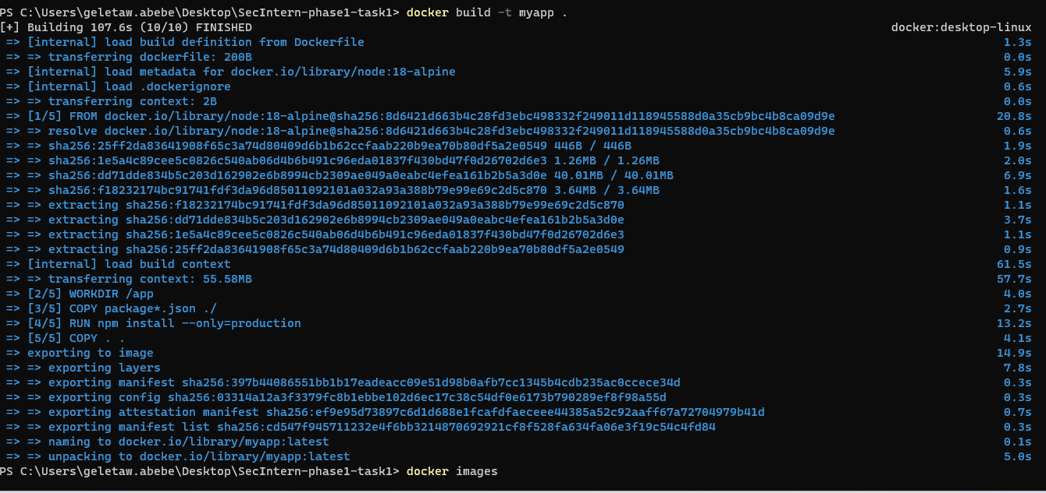

9. Conclusion
The application has been successfully audited and secured using industry-standard cybersecurity tools and best practices.
All major vulnerabilities have been mitigated, and the system now aligns with OWASP Top 10 security standards.
The final system demonstrates:
✔ Secure API design
✔ Hardened web server configuration
✔ Proper authentication and authorization
✔ Strong defensive security posture

